

**Activity 1.4.2 Objects and Methods**

Introduction

|  |  |
| --- | --- |
| In this lesson you will be creative with images. Starting with image files, you will load image objects into memory and then do interesting things with them. What are image files? They're data, really just zeros and ones. Images can be stored and retrieved like any other data files.  Once an image is in memory, we can perform a "simple" action on it like enlarging, brightening, or rotating it. These verbs abstract a complicated operation that can involve millions of calculations. When you move a window on the screen, click on a menu, or even just move the mouse, the pixels on the screen change. These are manipulations of images. In each case the central processing unit and the processors on the graphics card handle millions of ones and zeros to render fresh images on the monitor. How do we use objects and methods to handle these complex operations? |  |

Materials

* Computer with Enthought Canopy distribution of *Python*® programming language
* Webcam or other way to obtain a digital picture
* Practice file woman.jpg and cat1-a.gif

Procedure

1. Form pairs as directed by your teacher. Meet or greet each other to practice professional skills. Set team norms.

**Part I: Working with a Filesystem**

1. To open an image in a program, you will need a way to find the file using the programming language. You can use a file’s **absolute** **filename**. Most operating systems and programming languages remember one location in the file system as your "working directory," and a file can be described relative to that location: a **relative filename**. First we deal with absolute filenames.

Most file systems are hierarchical, forming a **tree** that begins with a **root** directory. An absolute filename specifies where the file is stored from the root, which is typically indicated by / in UNIX and Mac Operating Systems and by the startup drive letter in Windows, such as C:\.

Files and directories are **nodes**, each branching from one **parent** in the tree, with the root considered the “top” of the tree. The absolute filename of admin (in the green box below) is C:/Users/admin. What is the absolute filename of nice.jpg (in the red circle below)?

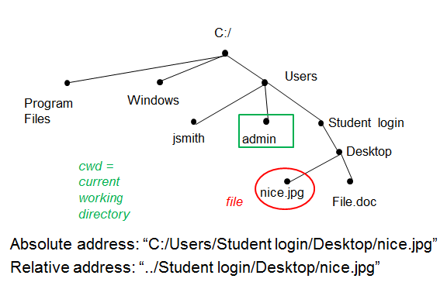

1. A filename can be specified with a **relative filename**. A relative name means that the file location is described starting from the current working directory. It does not begin with the root / or C:\. The special symbol of two periods .. is used by many languages to represent "up one level in the tree."

If we were currently working in the admin directory, what would be the relative filename for nice.jpg?

1. The table below lists the commands from UNIX for navigating the tree. Even when you run a *Python* environment on Windows or another operating system, *Python* will recognize these UNIX commands.

|  |  |
| --- | --- |
| **Command** | **Purpose** |
| pwd | Print working directory. |
| cd | Change directory. By itself, it means change to the user’s home directory. |
| cd .. | Move one level up toward the root. The double dot is an abbreviation for the directory above the current one. |
| cd *dirname* | Move downward in the tree into directory *dirname.* |
| ls | List all files and directories in the current directory. |

Try to navigate up the tree and back down into a different directory using these commands in the IPython shell. The IPython session below is an example. Your output will be different, and you will have to tailor your input to match the output in order to navigate up the filesystem.

In []: pwd

Out[]: u’C:\\Windows\\system’

In []: cd ..

C:\Windows

In []: ls

Volume in drive C is Win7Disk

Volume Serial Number is 1A7E-10ED

Directory of C:\Windows

05/07/2013 10:36 AM <DIR> .

05/07/2013 10:36 AM <DIR> ..

11/20/2010 04:29 PM 65,024 bfsvc.exe

07/13/2009 11:52 PM <DIR> Cursors

In []: cd Cursors

C:\Windows\Cursors

1. You may have noticed the double backslashes in the output shown above from pwd. The double backslashes are an **escape character**. Escape characters are multi-character codes that allow you type single characters that would be invisible or would have other effects. Quotation marks can be included inside a quoted string, for example:

'This entire string \' has a single quotation mark (in the middle) but no backslash!'

A few common escape characters are shown in the following table:

|  |  |
| --- | --- |
| **Escape sequence** | **Character** |
| \t | Tab |
| \n | Newline |
| \\ | Backslash |
| \' | Single quotation mark |
| \" | Double quotation mark |

How would you name the file C:\Windows\Cursors\cursor1.png using escape characters for the backslashes?

Is this an absolute filename or a relative filename? Do you have to be in a particular working directory for this filename to make sense?

**Part II: Rendering an Image on Screen**

1. Launch Canopy. Open an editor window. Set the working directory to your folder. Create a new *Python* file. Save the file as JDoe_JSmith_1_4_2.py.
2. Lines 12 and 14 of the code below create an absolute filename for an image by assuming that the image is in the same folder as your *Python* script. Use Windows Explorer to place files woman.jpg and 'cat-1a.gif' in the folder where you are saving *Python* scripts.

Earlier we used the code editor to define functions that we still executed in the IPython session. Coding in the code editor will execute directly with the “play” button” if it is not in a function definition. Execute the following code.

|  |  |
| --- | --- |
| 1  2  3  4  5  6  7  8  9  10  11  12  13  14  15  16  17  18  19  20  21  22 | '''  JDoe_JSmith_1_4_2: Read and show an image.  '''  **import matplotlib.pyplot as plt**  **import os.path**  **import numpy as np** *# “as” lets us use standard abbreviations*  '''Read the image data'''  *# Get the directory of this python script*  directory = os.path.dirname(os.path.abspath(__file__))  *# Build an absolute filename from directory + filename*  filename = os.path.join(directory, 'woman.jpg')  *# Read the image data into an array*  img = plt.imread(filename)  '''Show the image data'''  *# Create figure with 1 subplot*  fig, ax = plt.subplots(1, 1)  *# Show the image data in a subplot*  ax.imshow(img, interpolation='none')  *# Show the figure on the screen*  fig.show() |

You should see a new window displaying the image of a woman, perhaps hidden behind other windows. You can use **Alt**-**tab** to cycle through windows.

|  |  |
| --- | --- |
| The figures created by matplotlib are interactive **graphical user interfaces (GUIs)**. The GUI shows the coordinates of the mouse pointer, as shown at right. These coordinates are the image coordinates, more or less. (That's not quite true, since the coordinates shown by the GUI can be between integers, unlike the image coordinates. Also, we could have placed the image with its upper left corner somewhere other than (0, 0).)   1. What is the (x, y) coordinate pair of the woman’s nose in the image coordinate system? 2. Change the code so that it shows the cat. What are the image coordinates at the tip of the cat's nose? |  |

**Part III: Objects and Methods**

1. Consider lines 16-22 of the code from the previous step.
2. A **class** is a category of **objects** that have **properties** (a set of variables with potentially unique values for each object) and **methods** (a common set of scripts that do things). An object is an **instance** of its class.

In line 18,  plt.subplots(1, 1)  creates a 1 x 1 grid of subplots in a figure. It returns a 2-tuple. The first element of the tuple is an object in the class Figure. The second element of the tuple is an object in the class AxesSubplot.

The particular Figure object is being stored in a new variable, fig. The particular AxesSubplot object is being stored in the variable ax.

That was a lot of information! fig and ax are both objects. What class is each of them in?

fig is an instance of the class _________________

ax is an instance of the class __________________

1. In line 20 a method is being called on the object ax.

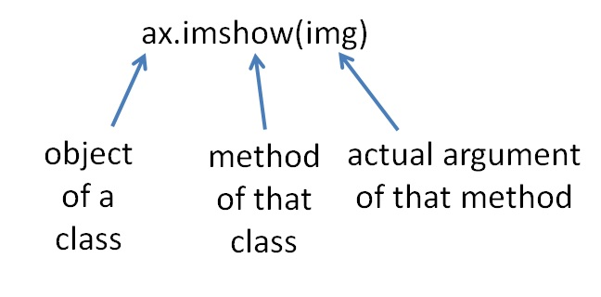

The method is imshow(). It is being given 1 argument: img. The imshow() method is being called on the ax object. Since ax is an instance of the AxesSubplot class, imshow() must be a method of the AxesSubplot class.

Similarly, in line 22, the method _______ is being called on the object ________. That method is being given ___ arguments. That method is a method of the class _________.

1. Comments help us undestand why a method is being called. Which comments explain which lines in the code above?

**Part IV: Arrays of Objects**

1. Methods often return data. Calling subplots(1, 1) returns a tuple of two objects:

(Figure, AxesSubplot)

The method subplots can also be used to create a grid of AxesSubplots, as shown below. In this case subplots (1, n) will return

(Figure, ndarray of AxesSubplots)

where ndarray is an n-d array, short for an "n-dimensional array." You can access the elements of an ndarray with an index in square brackets:

|  |  |
| --- | --- |
| 17  18  19  20  21  22  23  24 | *# Create a 1x2 grid of subplots*  *# fig is the Figure, and ax is an ndarray of AxesSubplots*  *# ax[0] and ax[1] are the two Axes Subplots*  fig, ax = plt.subplots(1, 2)  *# Show the image data in the first subplot*  ax[0].imshow(img, interpolation='none')  *# Show the figure on the screen*  fig.show() |

1. Modify lines 18 and 20 of your code to match what is shown above. You will have to re-execute the code to see the effect. Practice using object-oriented syntax by describing line 22: the method _______ is being called on the object ________.
2. Modify the code provided above to create the following figures:
3. An image of the woman in both of the subplots.

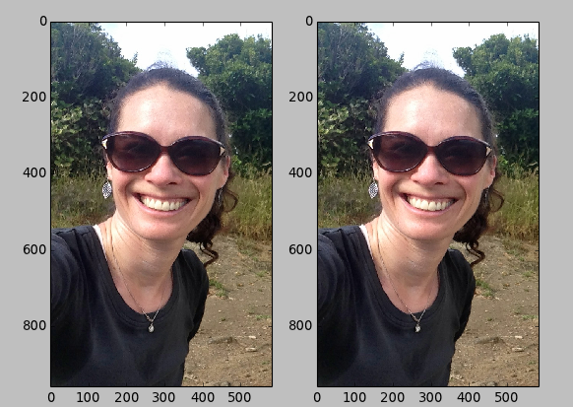

1. Iterated images of a picture:

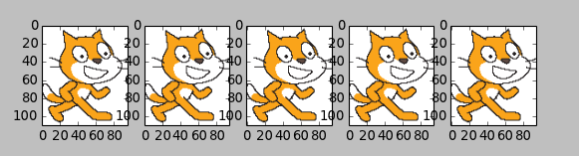

**Part V: Keyword = Value Pairs**

1. Methods and other functions often can be called with additional arguments. If you don't provide an optional argument when you call the function, the default value of that argument is used.

The imshow() method was called on both of the AxesSuplots shown below. For the axes on the left, the method was called with interpolation='none', whereas the axes on the right used the default value of the interpolation argument.

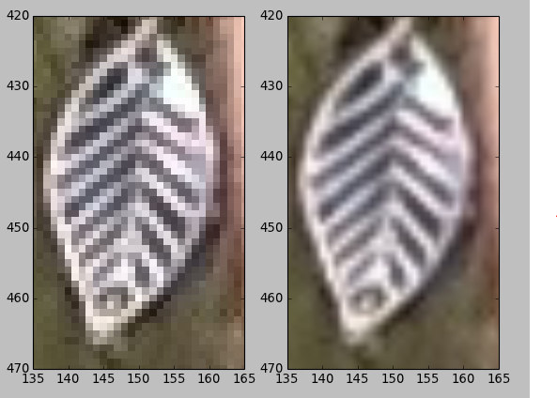

|  |  |
| --- | --- |
| 08  09  10  11  12  13  14  15  16  17  18  19  20  21  22  23  24  25  26 | '''Read the image data'''  *# Get the directory of this python script*  directory = os.path.dirname(os.path.abspath(__file__))  *# Build an absolute filename from directory + filename*  filename = os.path.join(directory, 'woman.jpg')  *# Read the image data into an array*  img = plt.imread(filename)  *# Create figure with 2 subplots*  fig, ax = plt.subplots(1, 2)  *# Show the image data in the first subplot*  ax[0].imshow(img)  ax[1].imshow(img, interpolation='none') *# Override the default*  ax[0].set_xlim(135, 165)  ax[0].set_ylim(470, 420)  ax[1].set_xlim(135, 165)  ax[1].set_ylim(470, 420)  *# Show the figure on the screen*  fig.show() |

The matplotlib interface will normally **interpolate** between values of the image pixels, inferring intermediate colors for screen pixels between the centers of image pixels.

The keywords of a function are often important ideas from the library's subject matter. Interpolating is an important idea in math. Describe the connections among interpolation between data points, the interpolation argument, the image above, and the code above.

1. An **API (Application Programming Interface)** for a class describes all methods you can call on objects in the class. Here are some of the methods from the API for AxesSubplot.

|  |  |
| --- | --- |
| **Some methods of** plt.SubplotAxes | **Description** |
| axis('on' | 'off') | Show/hide axes (and their titles and ticks)  *Documentation uses a vertical line | for “or”, showing that you can either* 'on' *or* 'off' |
| set_xlim(xmin,xmax) | Set lower and upper limits to x-axis |
| set_ylim(ymin,ymax) | Set lower and upper limits to y-axis |
| cla() | Clear axes |
| imshow(img) | Place an image on an axis |
| minorticks_on() | Show minor ticks |
| minorticks_off() | Hide minor ticks |
| set_xlabel(string) | Set x-axis title |
| set_ylabel(str) | Set y-axis title |
| set_xticks(list) | Set major ticks to label |
| set_title(string) | Set subplot title |

1. Experiment in IPython until you succeed in calling a couple of these methods on an AxesSubplot. After an object.method() call, you can view the updated figure with its canvas' draw() method.

Use fig.canvas.draw() after a change in an AxesSubplot

In []: ax[0].imshow(img)

In []: fig.canvas.draw()

Reminder: You can use the up arrow to avoid having to retype the draw() command each time.

1. Use the methods above to create three close-ups of an image in a single Figure. Each close-up should show a 10 pixel by 10 pixel region. An example using cat1-a.gif is shown here.

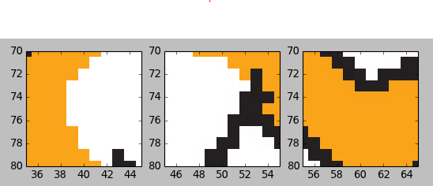

Share your work for this step as directed by your instructor, perhaps by showing the teacher your image on screen and by submitting a ZIP file of:

* the original image
* a captured image of the Figure as shown above
* your *Python* code

1. The ability to wade through documentation full of unknown terms is an important skill. Go to the documentation at <http://matplotlib.org/api/axes_api.html#matplotlib.axes.Axes.imshow>. This documentation is for the class Axes, which includes the AxesSubplot subclass. The link provided here points to the documentation for the imshow() method. From the documentation, identify one additional method of an AxesSubplot . Describe at least one of the optional arguments of that method and state its default value.
2. The class AxesSubplot has many methods for displaying data, including the plot() method.

plot(x, y, 'ro') places red circles (coded by 'ro') at all points ***(xi, yi)*** where x and y are lists of the ***xi*** and ***yi*** coordinates, respectively. In an image containing a few faces, mark the eyes with red circles using plot().

Share your work for this step as directed by your instructor, perhaps by showing the teacher your image on screen and by submitting a ZIP file of:

* the original image
* a captured image of the Figure
* your *Python* code

Conclusion

1. Describe similarities and differences between absolute filenames and relative filenames.
2. What is an object?
3. Objects have methods and properties. What are methods and properties?
4. What happens when you call a method on an object?